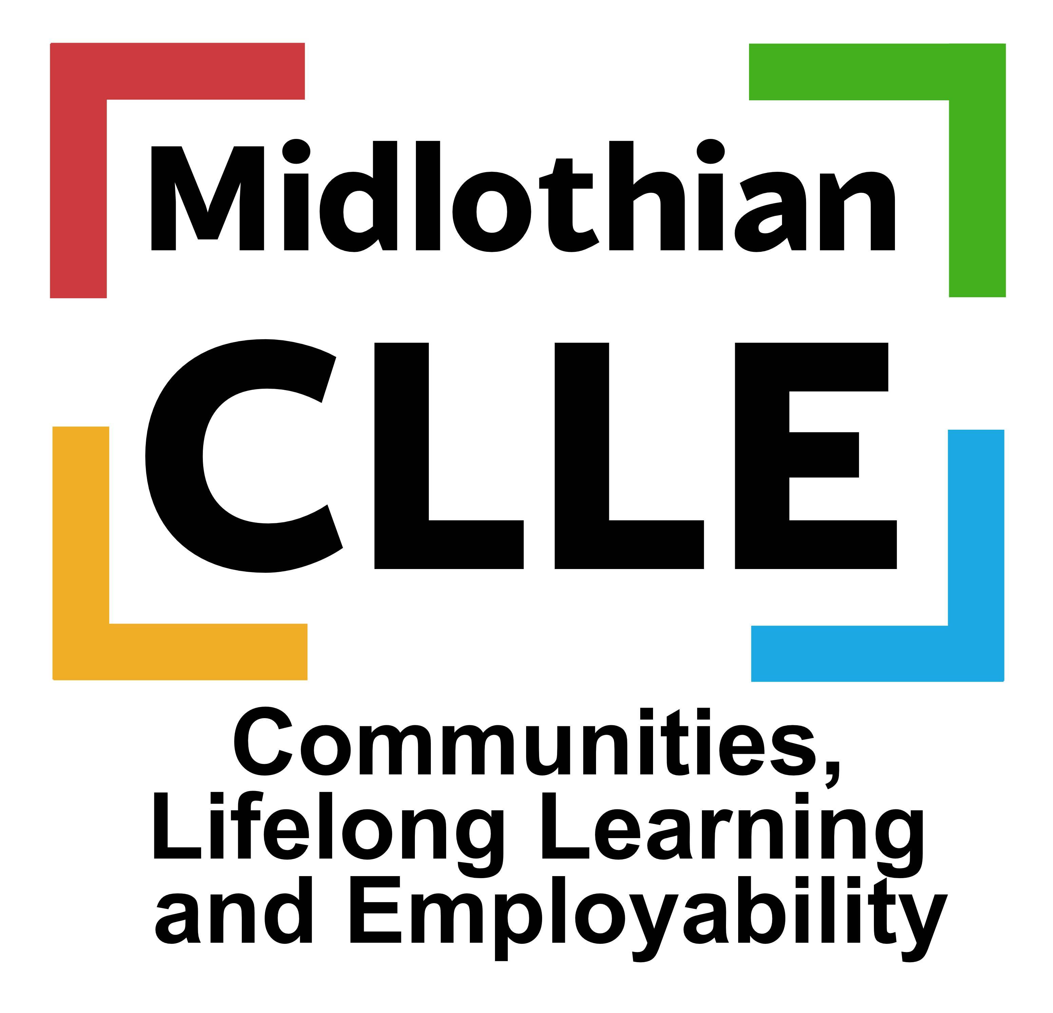
PARENTAL EMPLOYABILITY SUPPORT

Who are we? What do we do?

We help support parents (within a set criteria) who are in employment and looking to progress/upskill. We also work with parents who are unemployed to help them identify learning and training opportunities to gain qualifications, CV writing/job searching/interview skills, maximising household income, boost confidence or motivational support, gaining volunteer experiences etc. A small barrier free fund may be available to assist with modest costs.
If you would like to hear more about our service and what we can provide please get in touch.
The criteria for parents we work with is that they need to live in Midlothian and fit into one of these:
- Lone parent
- Disabled parent
- Parent with disabled children
- Parent with 3+ children
- Parent from an ethnic minority
- Parent with youngest child under 1 year old
- Parent aged under 25 years old
- Have a child or children who have a Good to be 2 place or a funded childcare place
Email: CLL@midlothian.gov.uk
Contact: Sharon Armstrong Tel: 07824383980

