HOME LEARNING – LIFE SKILLS
While you’re at home, take the opportunity to practise some important life skills. If you have a printer, print off this grid and colour in the boxes of the ones you have mastered. Don’t forget to post pictures on Google Classroom!
Change your bed covers- including sheet, duvet cover & pillowcase | Write a thank you letter for one of your Christmas presents. | Tie 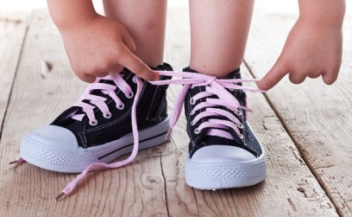your shoelaces | Follow a recipe to make a basic meal. There are some good recipes here to get you started:  https://www.eatsamazing.co.uk/category/family-friendly-recipes/easy-recipes-for-kids | Change a  light bulb.
Wrap a present. | Hammer a nail into a piece of wood – be careful! | Eat correctly with a knife and fork.  There are lots of videos on YouTube that can help if you aren’t sure what to do. | Wash your clothes in the washing machine. Remember to check the instructions on the washing powder or liquid so you know how much you use. Sort your clothes into darks and lights first! | Plant some seeds and help them grow. You can get free, bee-friendly seeds from here:  https://www.justbeedrinks.co.uk/seeds/
Draw a ma p. | 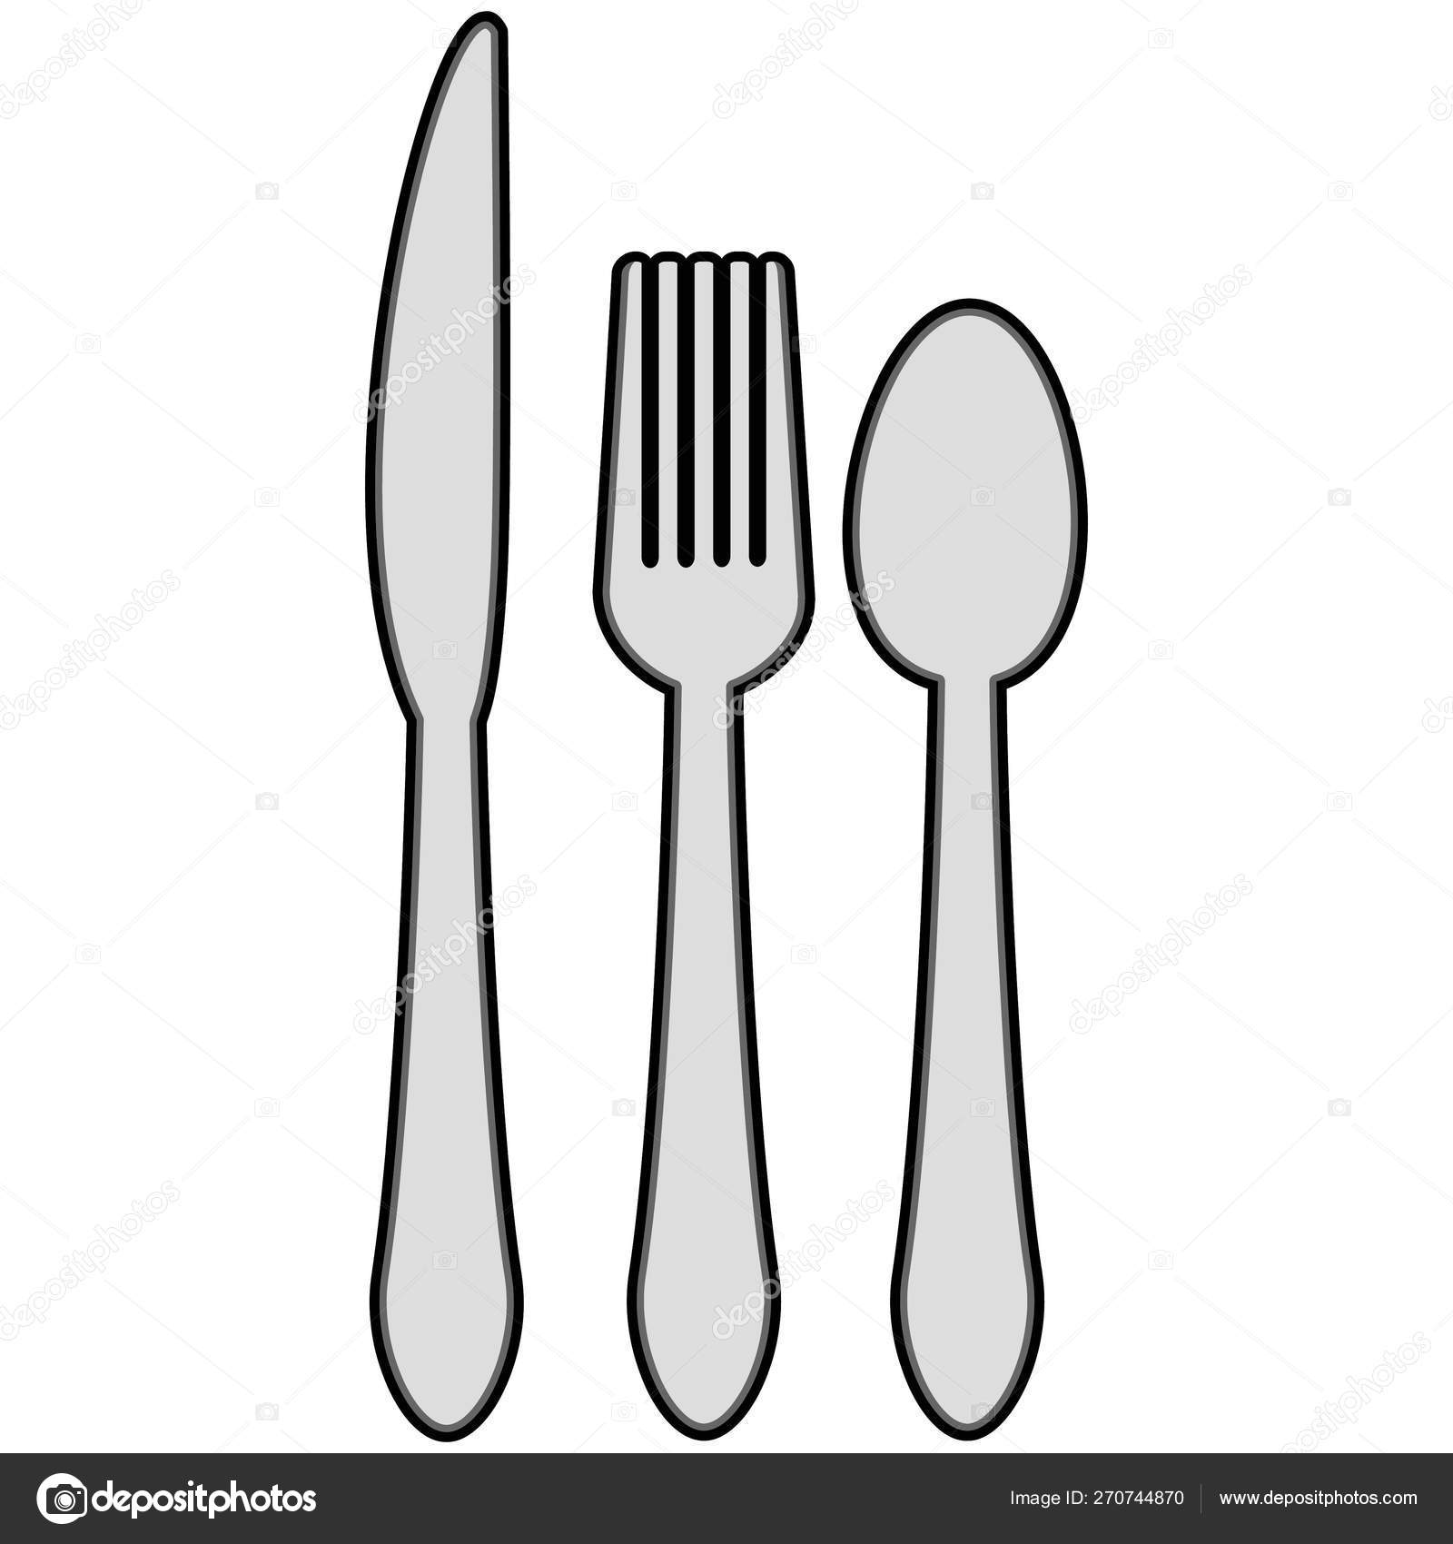  Set the table . | Load the dishwasher correctly (or wash the dishes if you don’t have a dishwasher. | 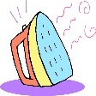  Iron a piece of your clothing – ask someone at home to help you if you’ve never done it before. | 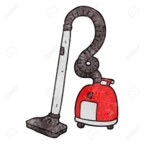  Hoover a room in your house.

