Literacy (Spelling)  Practice reading and spelling using Fry’s most common words. Use the method of Look, Cover, Write and Check to make sure you’ve got it right! Here are some other spelling ideas for you to practice words:  - Write over the vowels in blue a e i o u  -RAINBOW write over your spelling words.  - Draw a shape around your spelling words.  Fry’s first 100 most common words are below. A Phonics chart is also below for you to practice. | Reading  Try to read as much as possible at home. This can be stories, newspapers, magazines, ect. Ask your adults to read to you and listen to different stories too. There are often stories being read aloud online, try searching for books by Julia Donaldson, Dr Seuss or David Walliams.  Create a book review. In your review include details about the story that you liked or may you did not like. Explain why you liked or did not like the book. What would you add to the story.Try creating your own character. What is the characters name,  Log on to Education City and I will have given you some work to do. | Maths  - Practice recognising your 3D shapes, see if you can find them in your home and write down what shapes you found. For example, an orange or a football would be a sphere.  - Practice telling the time. Try recognising quarter past and quarter to, half past and o'clock on an analog and digital clock.  We are due to be moving on to learning about money – see if you can become familiar with each coin and how much it is worth (1p, 2p, 5p, 10p, 20p, 50p, £1 and £2. Start to work on counting different amounts of each coin.
Writing  Keep a daily diary about what you have been doing. Draw a picture of what happened, including any people, animals and toys. Remember to include the setting! Think Who, What, Where and Why. Remember to add nouns, verbs and adjectives to help you add detail. Remember to use F-R-E-D fingers to sound out words you don’t know.  When practicing our sounds we follow a program called Read, Write, Inc. Ask an adult if they can help you to practice your sounds and special friends (chart below). !  Use your imagination to come up with a story. Maybe it is set in ancient Egypt inside a pyramid, or maybe the story is set right here in Gorebridge! Remember to include a beginning, middle and end. Draw a picture for each part of your story first, this will help you when you are writing. | Primary 3  Home-Learning  2022 | Numeracy  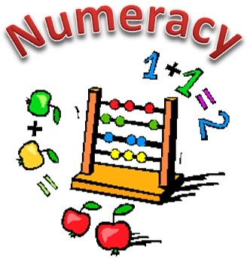  - Practice place value. Ask an adult to tell you a 3 or 2 digit number. See if you can separate that number into hundreds, tens and ones. H T O  -Practice you 2, 5 and 10 times table  Log on to Education City, find new learning in homework. You know the level you are on, challenge yourself with some extra activities!
RERC

Prayer checklist: Do you by memory –
- ‘The Lord’s Prayer’,
- ‘Hail Mary’

Google them and write them down, then try and memorise.

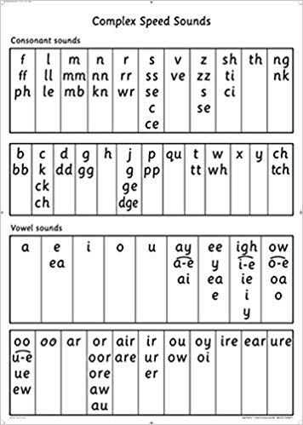
Practice your phonics here! Remember, if it is in the same box then it makes the
same sound! Can you remember its rhyme? Ask your adult to say a sound and
use your finger to point to it!
