Literacy – writing  We are developing our ability to write independently  - Use the word list below to practise writing your words – remember to say the word, count the sounds, pinch the sounds, write and then check.  - You could also try to ‘hold a sentence’ using the sentences below. Hold the sentence in your head and try to write it. An adult can help you remember the sentence if you get stuck. Remember finger spaces!  - Handwriting-Practise writing all your sounds. You could use the whiteboard that came home in your book bag. | Literacy – phonics  We are learning our letter sounds  We are learning to read cvc and tricky words  - Below is a speeds sound chart – ask an adult to point to the sounds you have learned and read them. Then an adult should say a sound; use your fastest finger to find the sound. You can also use your flash cards.  - Use the words below to practise reading green words. Use Fred talk to sound these out.  - Practise reading and recognising red words. | Literacy- Fine motor skills  We are strengthening our hands for writing  - Practise your cutting skills. Maybe cut pictures of toys from a magazine? Remember, fingers on the bottom and thumb on top!  - Play with construction at home. You could play with building blocks, Lego, K’NEXS etc.  - Work with an adult to make some playdough (link below). Then use it to squash and roll to create different things.  https://www.bbcgoodfood.com/howto/guide/playdough-recipe
Numeracy  We are developing our counting skills and gaining a further understanding of numbers  - Count forwards and backwards, try to count to 20.  - Practise writing your numbers to 20. Remember to write your numbers the correct way around.  - Use your number flash cards for number recognition.  - Use items around the house to do simple addition. 5 pegs + 2 pegs =  - Have a look at these online games:  Learning to Count with these fun Counting Games (topmarks.co.uk)  https://www.bbc.co.uk/cbeebies/shows/numberblocks | Primary 1 Home Learning Wall  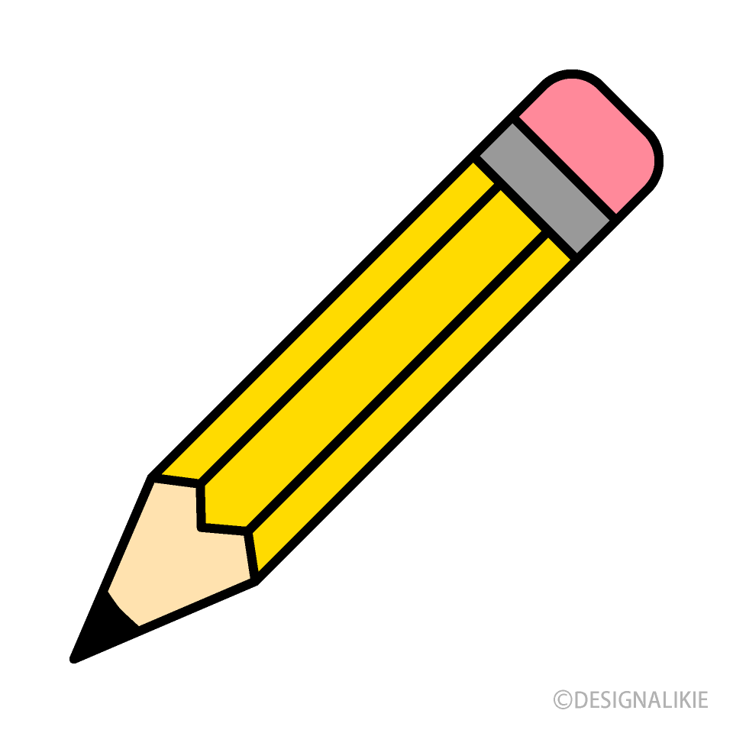 | Maths  We are learning about Money  - Recognise the symbols for ‘pound’ (£) and ‘pence’ (p) – can you find them in your environment, in books, on the TV etc.? Practise forming the pound and pence signs.  - Begin to recognise coins from 1p-£2 – can you match them, put them in order?  - Use 1p coins to make the same value as 2p, 5p, 10p and 20p.  - Use different coins to make the value of 10p.  There are tasks for you to complete in the ‘My City’ portal of Education City – log on and complete the tasks set (I sent your logins home).  https://www.topmarks.co.uk/money/coins-game  https://www.topmarks.co.uk/money/toy-shop-money

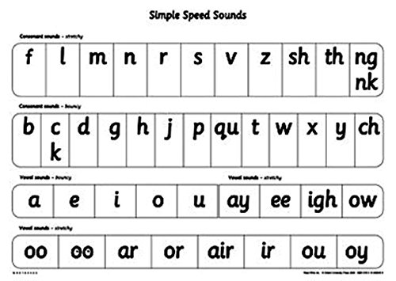

Hold A Sentence
I can run.
The cat sat on the bed.
A red hen.
I can zip up.
I ran to the shop.

cat | sit | fin | tap | fog
tin | map | lip | let | fat
fan | sip | top | tip | ten
man | men | pat | six | tap
lap | zip | put | lot | zap
it | is | in | at | up
on | can | lap | pan | box
fox | lad | top | tin | mix

Red Words (words we can’t sound out)
I
of
my
to
the
no

Green words

