HOME LEARNING – LIFE SKILLS
While you’re at home, take the opportunity to practise some important life skills. If you have a printer, print off this grid and colour in the boxes of the ones you have mastered. Don’t forget to tweet any of your work to us! @MrsWiseman3 @MrsValentine101
Change your bed covers- including sheet, duvet cover & pillowcase | Hang your clothes on a coathanger | Tie 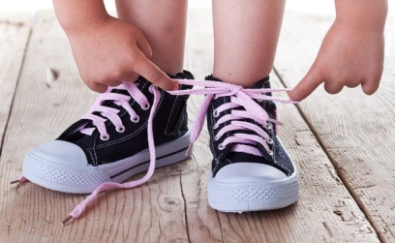your shoelaces | Follow a recipe to make a basic meal. There are some good recipes here to get you started:  https://www.eatsamazing.co.uk/category/family-friendly-recipes/easy-recipes-for-kids | Change a  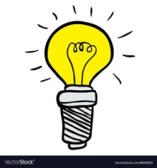  light bulb.
Wrap a present. | Hammer a nail into a piece of wood – be careful! | Eat correctly with a knife and fork.  There are lots of videos on YouTube that can help if you aren’t sure what to do. | Wash your clothes in the washing machine. Remember to check the instructions on the washing powder or liquid so you know how much you use. Sort your clothes into darks and lights first! | Plant some seeds and help them grow. You can get free, bee-friendly seeds from here:  https://www.justbeedrinks.co.uk/seeds/
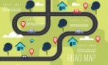  Draw a ma p. | 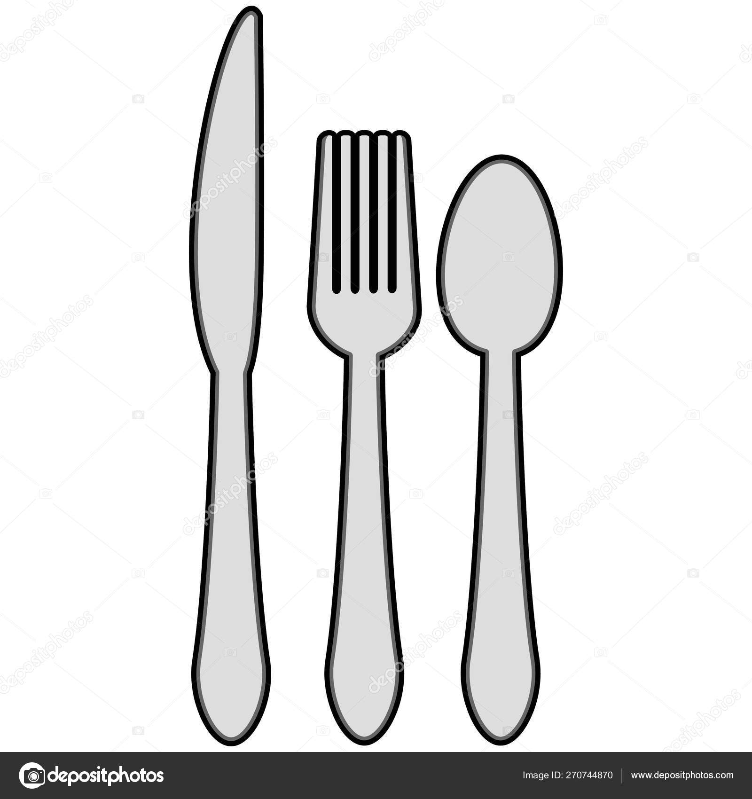  Set the table . | Load the dishwasher correctly (or wash the dishes if you don’t have a dishwasher. | Log in to GLOW (passwords coming soon) and use the waffle menu next to your name to find Outlook email. Send someone an email. | 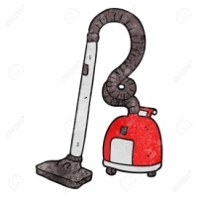  Hoover a room in your house.

