1.Literacy – Reading  -We are exploring texts and learning to identify letters, words and sentences.  - Choose different books and texts to read at home.  - Can you point to a word, sentence or letter on a page? Try to Fred Talk some of the words. Also see if you can split any of the words into syllables (claps).  - I will try to upload a video each week using green word cards for you to read. Keep an eye on my twitter page. | 2.Literacy – Phonics  -We are learning our letter sounds.  - Continue to practise all sounds learned so far. Use the words below to practise reading green words.  - Below is a speeds sound chart – ask an adult to point to the sounds you have learned and read them. Then an adult should say a sound; use your fastest finger to find the sound.  - I will try each week to upload a video of a new sound for you to learn/practise. | 3.Literacy- Writing  -We are developing our ability to write independently  - Use the word list below to practise writing your words – remember to say the word, count the sounds, pinch the sounds, write and then check.  - You could also try to ‘hold a sentence’ using the sentences below. Hold the sentence in your head and try to write it. An adult can help you remember the sentence if you get stuck. Remember finger spaces!  - Practise writing the words from the videos I upload (these will link to the sounds being learned).
4.Health and Wellbeing  We are learning about different relationships.  - Talk to an adult about different people who can help you - include people at home, school and in the community.  - Talk about relationships with your friends/peer at school – discuss how you know when someone is a good friend.  - Draw a picture for a friend at school and write a little note to them (an adult can help you with this!). Tweet a picture of it to me so that I can share it. | Primary 1 Home Learning Wall  Remember to tweet your work and tag @StAndrewsTweets and @MissEssTweets so I can give feedback | 5.Numeracy  We are developing our counting skills and gaining a further understanding of numbers.  - Continue to count forwards and backwards, try to count to numbers higher than 30.  - Practise writing your numbers to 30. Remember to write your numbers the correct way around.  - Use your T-Jay booklets to continue your number practise.  - Practise adding and taking away different numbers – use counters to help (practise having one or both collections screened).  - I will try to upload different videos to help you and to give you ideas for different activities
6. Religous Education  -We are learning about the Easter Story.  - Watch the story of Easter on YouTube: https://www.youtube.com/watch?v=0PSgoPdKQFQ  - Participate in some Easter activities – you could design your own Easter egg in your jotter, hard boil eggs and decorate them, bake some Easter biscuits, create your own Easter basket etc. | 7.Maths  -We are learning about Money.  - Continue to recognise coins from 1p to £2  - Continue to work on the value of each coins, using 1p coins to show the correct value of the other coins (up to 20p)  - Complete pages in your T-Jay workbook (please do not do more than 4 pages before the Easter Break).  - Begin to work on giving change up to 10p (using 1p coins) | 8.Topic/Theme  -We are learning about the weather  - Practise saying the days of the week/months of the year in order. There are lots of fun videos/songs on YouTube to help you remember this and become more confident with the correct order.  - Use this video to learn about shadows - https://www.youtube.com/watch?v=lOIGOT88Aqc Create different shapes in your shadow. Can you draw around different shadows?
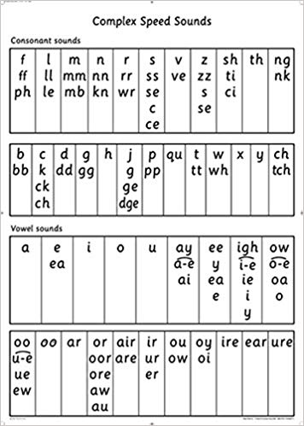
Hold A Sentence
I can run and jump.
Is it a dog?
I feel sad and upset.
Will you bang the drum?
Stop! A fox is in the box.
The red hen ran up the path to the farm.
Words to Practise Writing
Cat Met Fan Lip Shop Thin
Red Run Yes Web Wish Sock
Zap Zig Chop Bang Thing Quit
Bell Best Jump Fox Flop Grin
Black Stink Hand Dress Stop Bend
Strop Stamp Kitchen Seven Rabbit Trap

