
ST ANDREW’S RC
PRIMARY SCHOOL
Gowkshill, Gorebridge
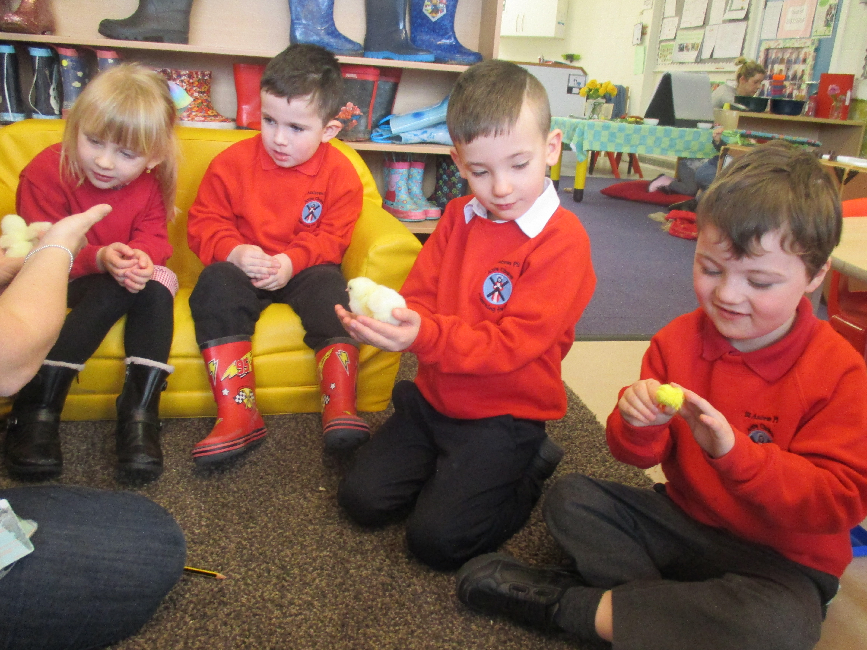
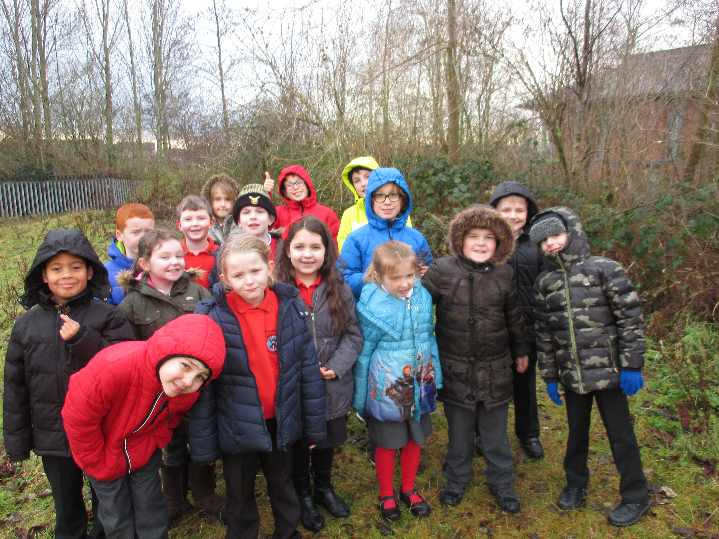
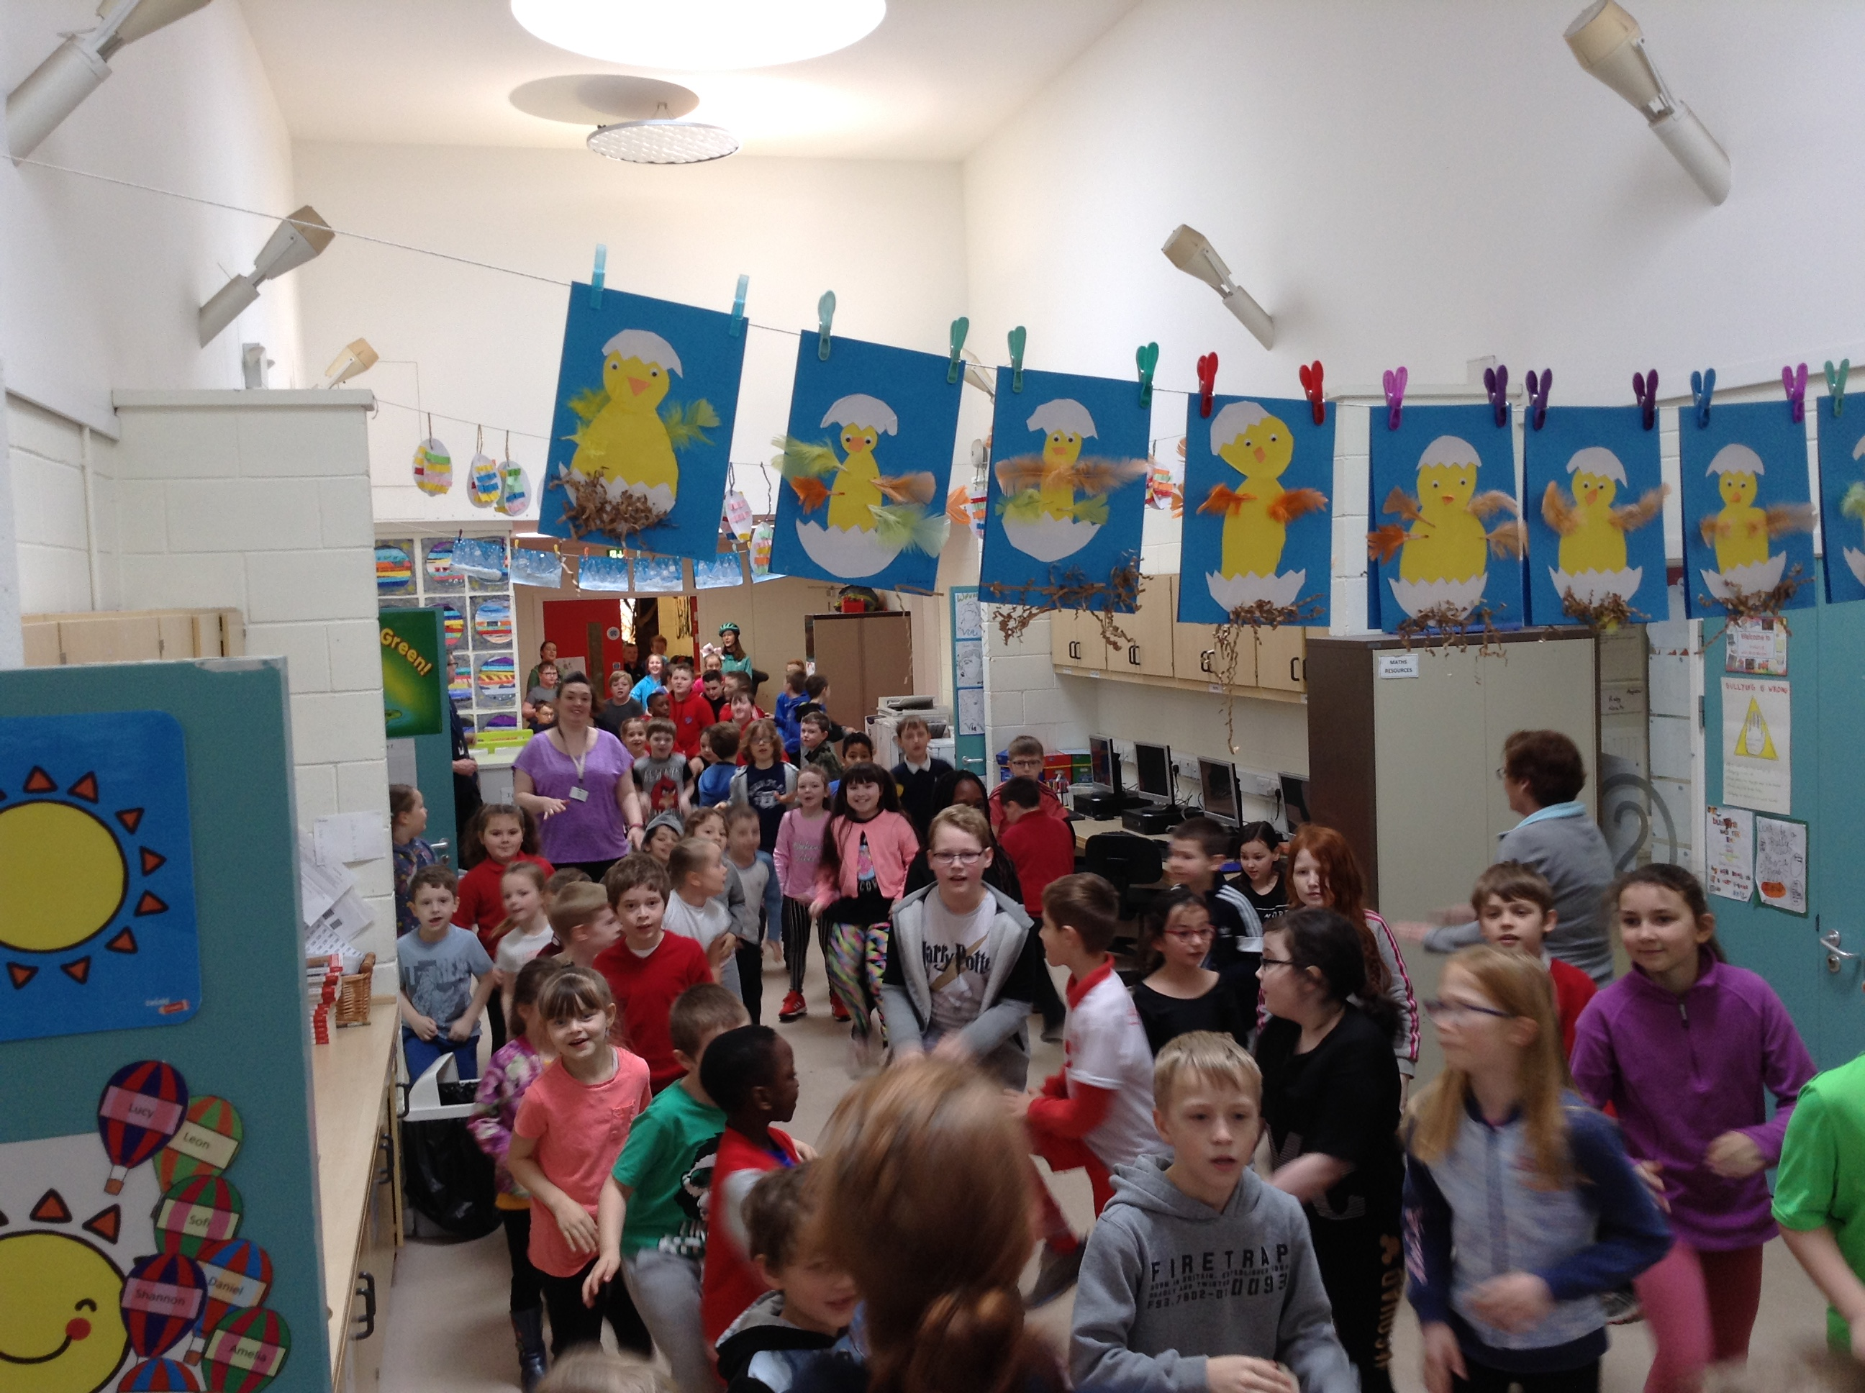

IS YOUR CHILD DUE TO START PRIMARY 1 IN AUGUST 2019?

We would like to welcome you to our Registration day on:

MONDAY 19th NOVEMBER 2018

PRESENTATIONS AT 8.45am and 3 pm
by HEADTEACHER, LIZ LAIRD
followed by Guided Tours of the school

Please bring your child’s Birth Certificate,
proof of Baptism, if appropriate,
and proof of address in the form of
a Utility or Council tax bill or a Child Tax Credit letter.

If you are unable to attend at this time, please call the school on
0131 271 4670 to make alternative arrangements.

We look forward to meeting you

Sent to:
St Margaret’s Church
Gore Glen Nursery
Newtongrange Nursery
Gorebridge Library
Medical Centre
Newbyres Nursery
After School Club
Gorebridge Primary School
Morelli’s Cafe
Stobhill Primary
Tesco & Tesco Express
Scotmid

