Primary 1’s activities included:
Edinburgh’s Children’s Book Festival in August. Magic Mike’s Road Safety Show
The Panto in December at the Brunton Theatre, Mussleburgh.
A real author came to read his work and chat to us.
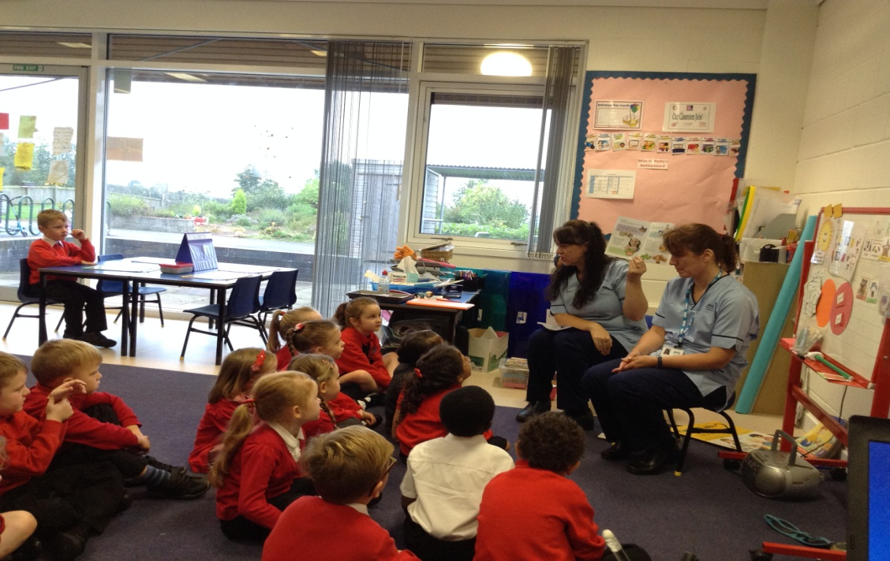
The National Museum for an African safari workshop.
The Science Centre in Glasgow where we had a planetarium workshop.
The Dental nurses help P1 with their teeth brushing.
We had visits from People Who Help Us: Dental Nurse, Community Nurse, and the SSPCA.
We also became members of our local library and make monthly visits to hear new stories and sing songs together.

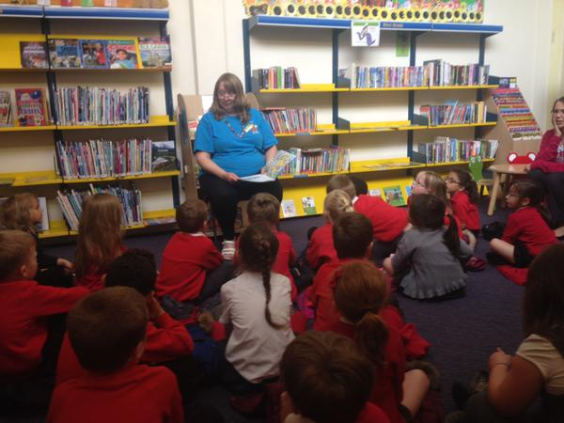
P1 love their monthly library visits.

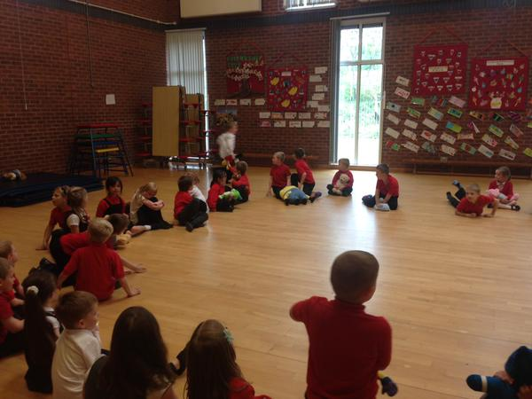
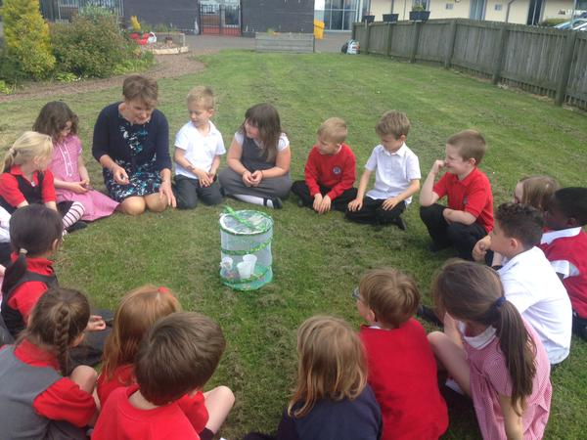
P2 kicked off the year with a visit to the Book Festival. They visited Newtongrange PS to see a performance of The Jungle Book and attended the Christmas Pantomime at the Brunton Theatre along with the whole school. They too enjoyed the Road Safety Road Show with P1 as well as a visit from the SSPCA. In June Mrs Baxter was brave enough to take the children to visit the Water of Leith! It looks like they’ve turned into water babies.
P2 share a teddy bears picnic with P1 and nursery
P2 releasing their butterflies they grew from caterpillars in their classroom

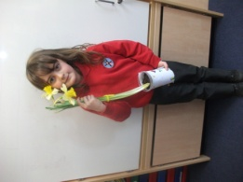
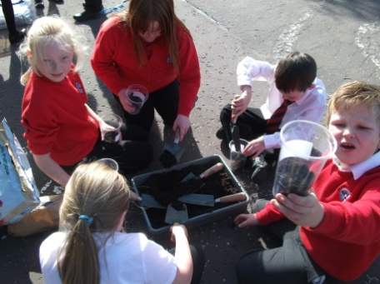
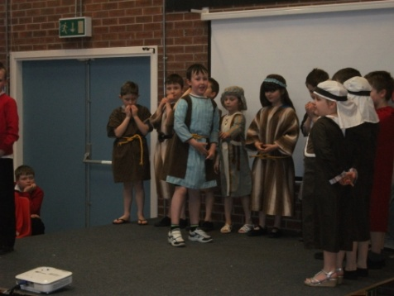
Since it was a whole school event, P3/4 also attended the Edinburgh Book Festival where they had great fun listening to Johnny Duddley’ Pirate Stories. The fun continued with the Road Safety Show and the Brunton theatre Christmas Panto. Miss Allum demonstrated how different school is now compared with Victorian times when she took the class to the Victorian Classroom in Edinburgh. Health and Wellbeing is very important to us all at St Andrew’s and the kids from P3/4 were lucky to have been included in the Food Standards Agency Football programme. They got together with P4/5 to present the Easter Story which was a huge success and very moving. In the final term they were involved in the end of year production, ‘Secrets in the Attic’. What a year!
Displaying our acting skills in the Easter Production
Getting green fingers in the garden!

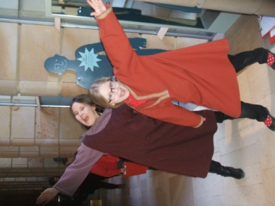
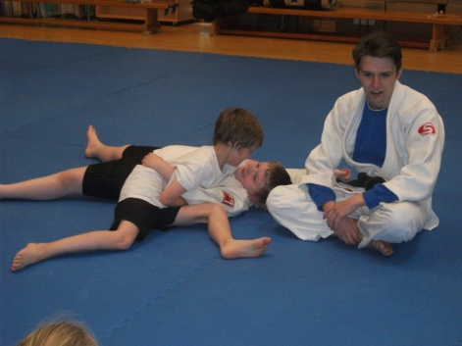
P4/5 set the ball rolling by attending a presentation by author Matt Brown at the Edinburgh Book Festival. Along with the other classes P4/5 had a great time at the Brunton Theatre Panto, Jack and the Beanstalk. They followed that up by a Rainforest Tour in the Botanic Gardens the off to the Film Festival some time later to see Rio 2 for their Social/Eco studies. It wasn’t long before they decided to go exploring again and this time they decided to visit the museum where they took part in the Viking Experience investigation People in the past.
Living as Viking citizens
Getting to grips with judo

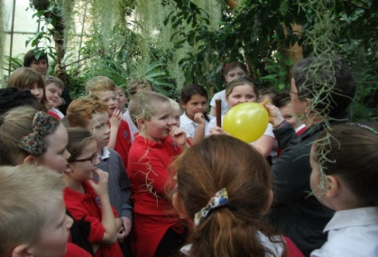
Using our local library they attended a story telling session on Scottish Tales. As the Coordinator of our Fair Trade Pupil Voice Group and in support of our Citizenship ethos, Mrs Hunter organised a visit to Scotmid in Gorebridge. Not quite content with all this activity, she then decided P4/5 were in need of exercise so, in conjunction with Active Schools, the class attended the Rugby Festival, had Judo lessons, and P4 took to the water with a series of swimming lessons.
Discovering the wonders of the Rainforest

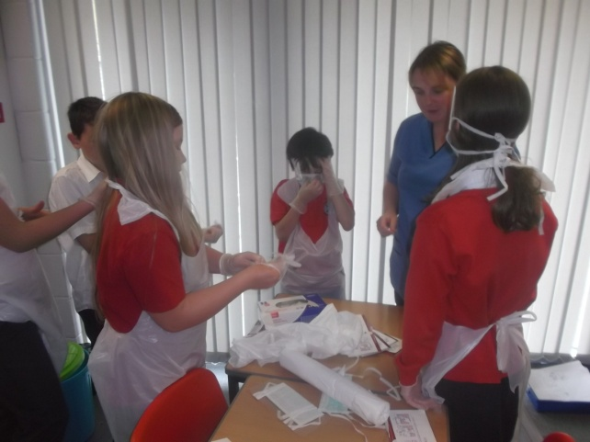
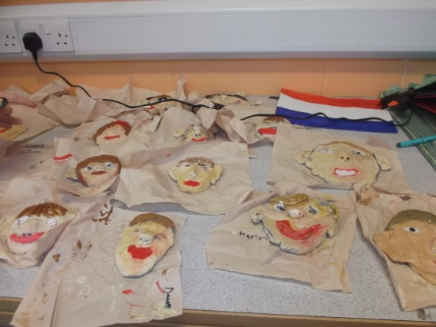
Along with the other classes, P5/6 enjoyed the Book Festival and the Christmas Panto. On their two visits to the National Art Gallery on the Mound, they completed a challenge worthy of high school pupils and really got to know about the artists and their work. At the Glasgow Science Centre P5/6 confirmed their belief in science being fun. The kids got really involved in the end of year production, Treasures in the Attic, which they helped write and star in. They performed in the Pied Piper section of the show to an appreciative audience of family and friends. The class made full use of the local library visiting for live author events and talks with the librarian, Elaine. Since the class was composite the P6 children enjoyed skiing lessons making huge progress while the Actives Schools programme activities that the class engaged in helped
Learning skills as a nurse
Getting up close and personal in our clay art project
keep everyone fit. They also took part in an all school skills 2 day event, getting hands on with real job experiences.

As with the other classes, P6/7 had a verity of rich experiences throughout their year kicking off with the Book Festival and continuing with a wealth of sport from skiing in October, the Rugby Festival in November to Sports hall Athletics. As part of their Nobody was going to keep these kids down, they went on to co-write their own end of and the Creative Arts team, Mrs Dot Smith and Cheryl Aird. We were all particularly proud to see how well they “Buddied up” to support all the younger children at our first ever annual picnic.

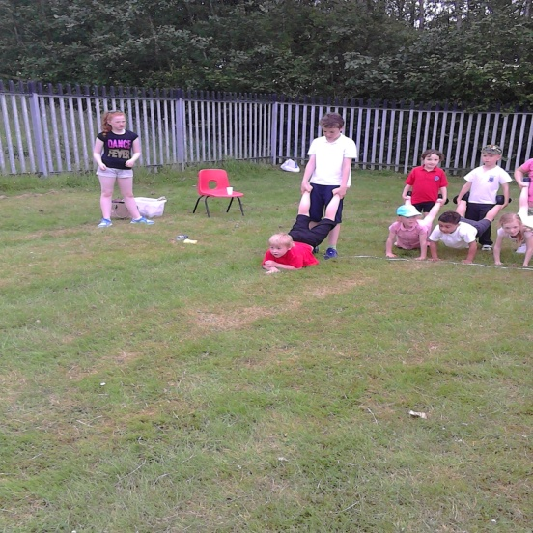
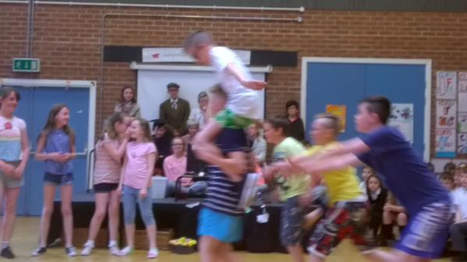
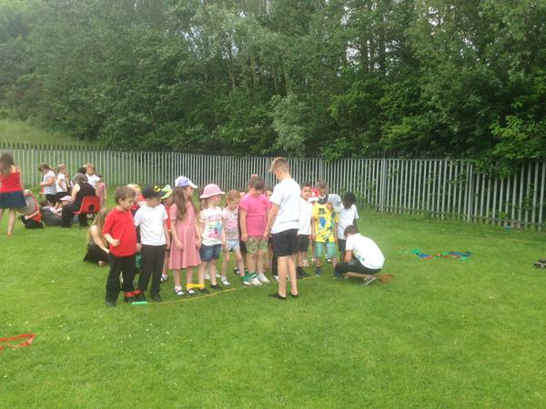

1 End of term show

2School Picnic
3P7 led games at our annual school picnic

4P6/7 French Cafe Experience!

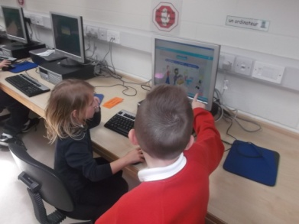

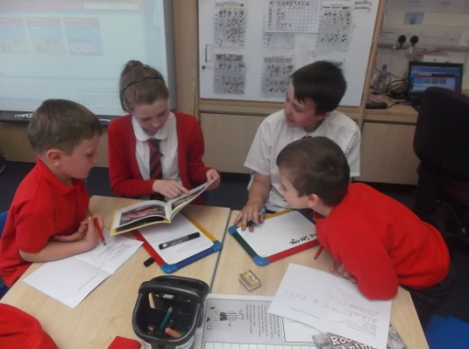
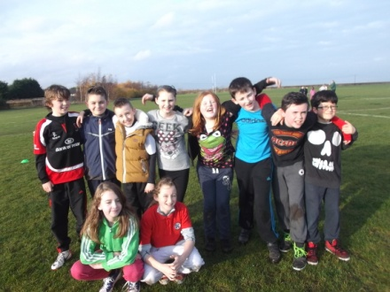
5Enjoying the sun at the Rugby Festival

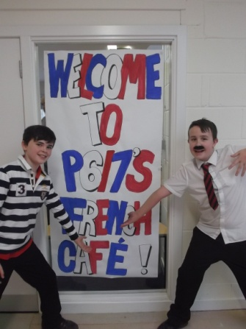

Rugby Festival

6P7 buddies working with P1

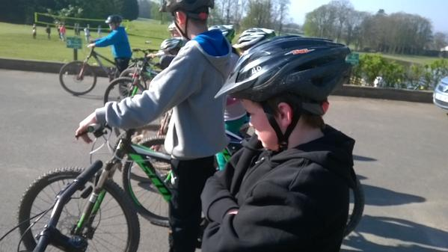

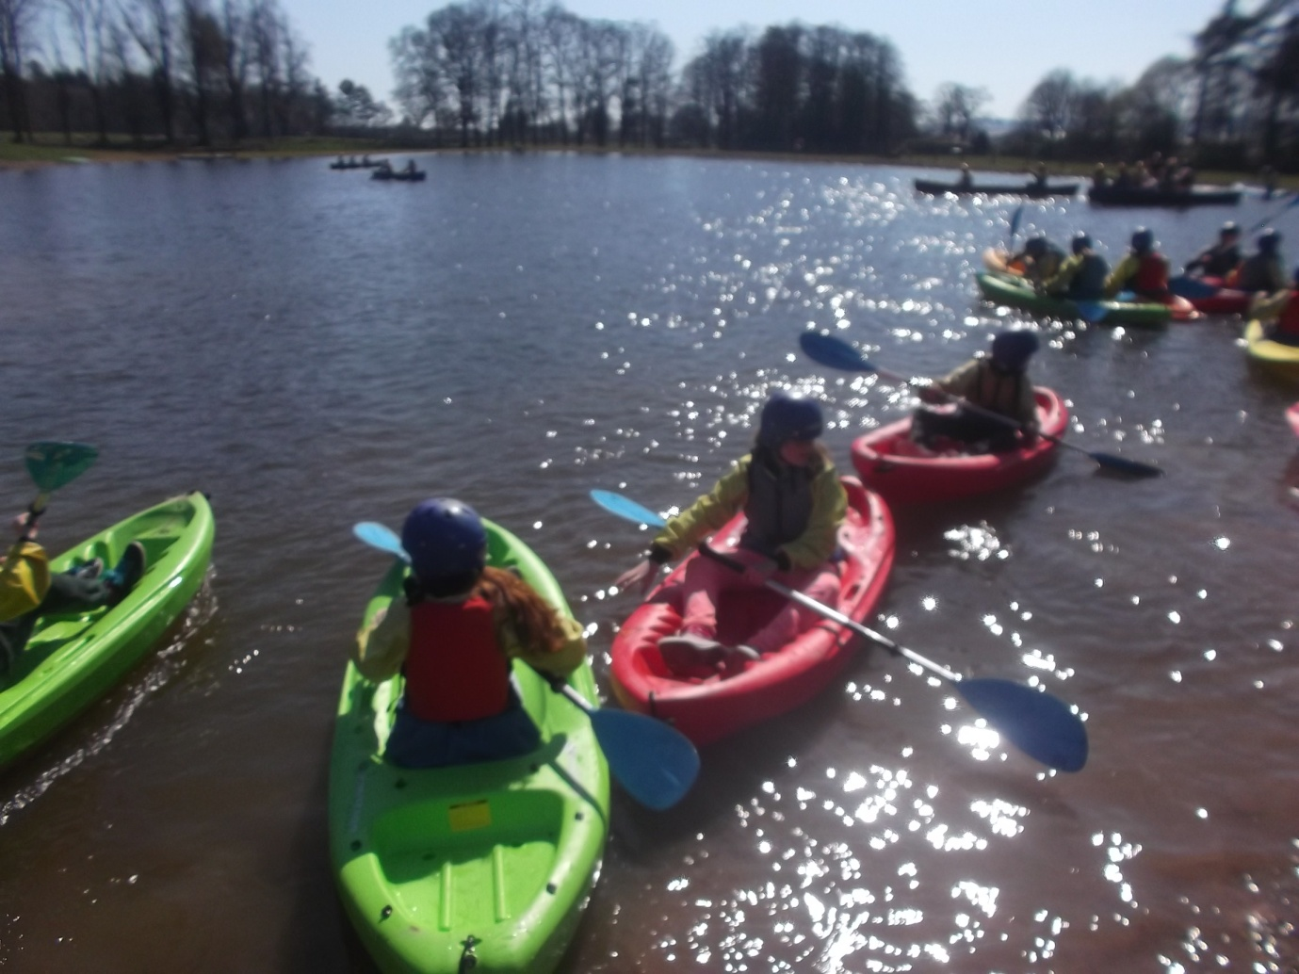
Learning new skills with new friends

This year at Lockerbie Manor proved to be even better for the P7 kids. They had a great time and everyone enjoyed the experience and gained from it.
This a valuable way of transitioning from primary to secondary and, having had long chats with children who have been to P7 camp, I recommend the experience unreservedly.
Mountain Biking

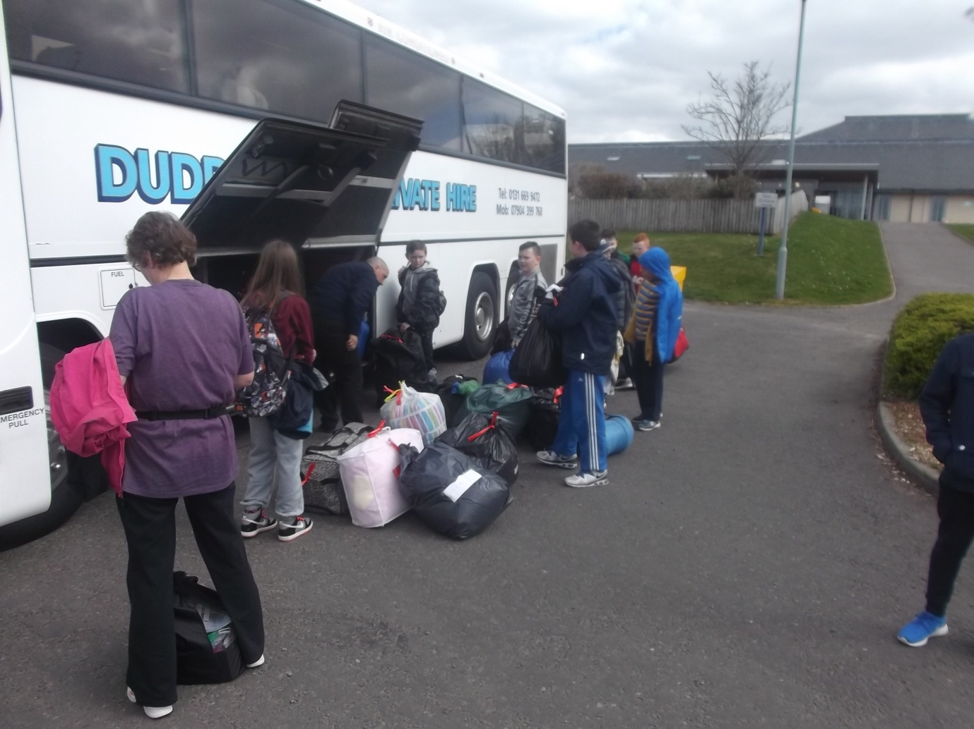
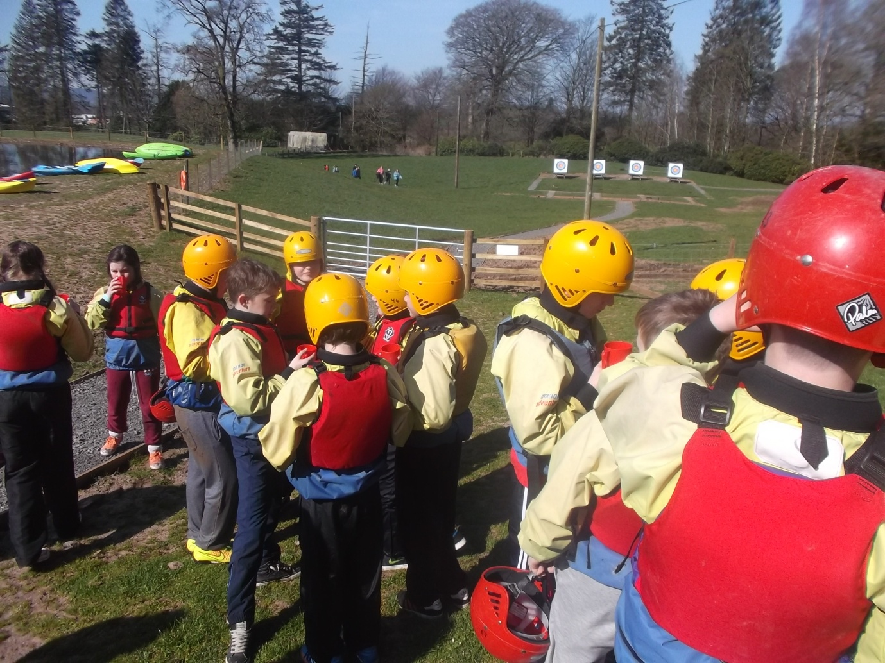
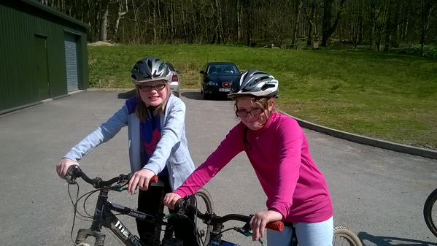
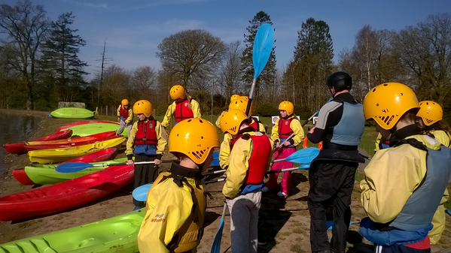
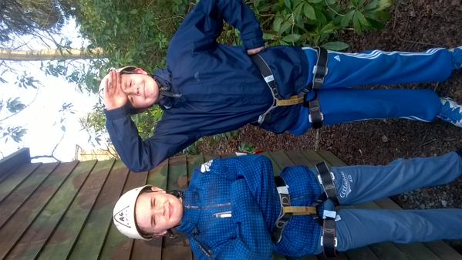
Getting wet and wild.
Ready to climb!

