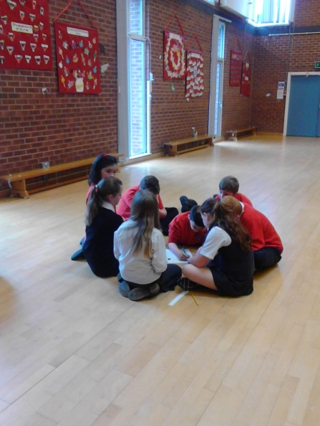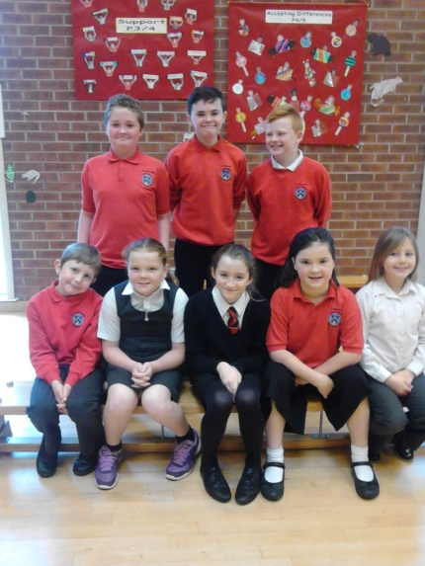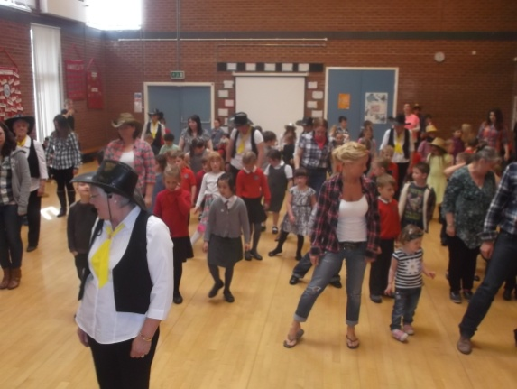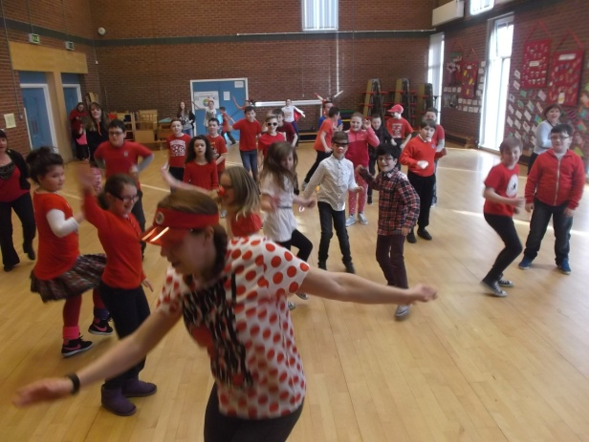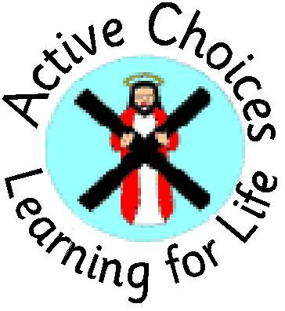

Putting our heads together

Our Pupil Council 14-15

Nepal Appeal Line Dancing

**PUPIL COUNCIL**

**To represent the pupils throughout the school so that we can all work together to make the school even better**

**Worked as a team to represent the pupils.**

**Designed and collated questionnaires for better information about what the pupils think.**

**Organisation of fundraisers: RED NOSE DAY £383.25**

**NEPAL APPEAL £278.42**

**SUPPORT P1 TRIP £145.00**

**GRAND TOTAL £806.67**

**To become more independent.**

**To become more familiar with the software.**

**To become more effective at proofreading copy.**

**WHAT DID WE ALL ACHIEVE?**