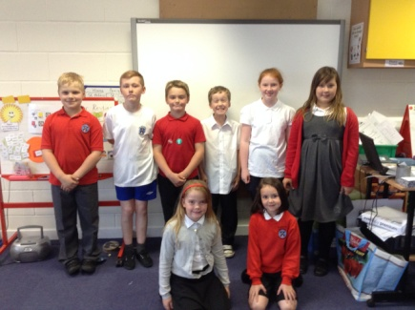[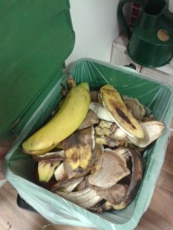](http://twitter.com/EcoSchoolsScot/status/573139617047695361/photo/1)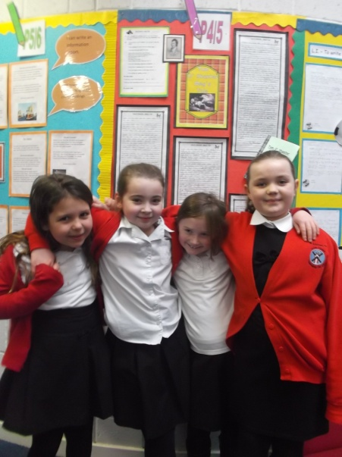

Winners of our Burns Competition with photo taken by the Newshounds

Our Eco Team 14-15

**ECO WARRIORS**

**To make the children and parents more aware of ECO matters**

**Devised a better system for recycling**

**Organised Green Santa event recycling old toys to give to charity**

**Ran a Christmas challenge**

**Got new compost bins for school and arranged teams to empty them daily**

**Kept the ECO notice board up to date**

**To achieve our silver flag**

**To continue to work at the lunch hall recycling system and compost system**

**To design more posters and signs to raise awareness round the school**

**WHAT DID WE ALL ACHIEVE?**

**NEWS HOUNDS**

**To produce excellent news items so that staff and children are encouraged to access our website**

**As class reps we investigated stories, wrote them up, sourced supporting photos**

**Conducted staff interviews**

**Produced interesting articles and stories**

**Worked together as a team**

**To become more independent**

**To become more familiar with the software**

**To become more effective at proofreading copy**