**WHAT DID WE ALL ACHIEVE?**

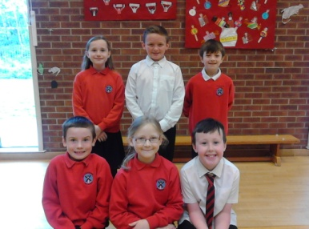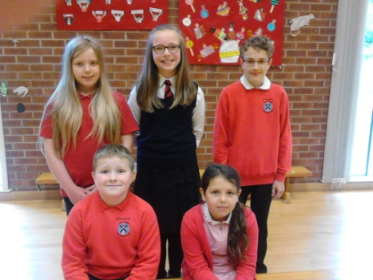

Leading the School in fairness for all.

Our responsible Junior Road Safety Officers

**FAIR TRADE**

**To help people understand the**

**Importance of the Fair Trade movement**

**Held Fair Trade events and fundraisers – Coffee Mornings using Fair Trade products and building community relationships with the local Cooperative, designing and colouring competitions**

**We raised £292.70 which we sent off to Fair Trade HQ Supporting Fair Trade farmers by the work our Fair Trade group does**

**To conduct more fundraising throughout the year rather than the one big push during Fair Trade fortnight. To continue to raise awareness of the need to support the movement**

**J.R.S.O.**

**Raise awareness about ROAD SAFETY.**

**Designed posters to keep children and young people informed of the dangers of the new Borders Railway, where to cross the road and refresh Safer Routes to School**

**Give presentations at assemblies to teach children what to wear on their bikes for safety day and night**

**To continue to present at assemblies**

**To get the parents more involved**

**To hold competitions for producing awareness posters**